SAMA: Sustainability Awareness Platform

User Manual

## Introduction

SAMA is very user friendly and the usability level is very high. Most users did use it directly without any help due to following standard HCI (Human Computer Interaction) design principles, and considering the feedback from users in the surveys. Figure 1 presents the UI screens and Table 1 presents a brief description of each screen. The UI was designed using Figma and PowerPoint, and deployed on Android Studio as XML. In the following, we will view and explain the usage of each screen.

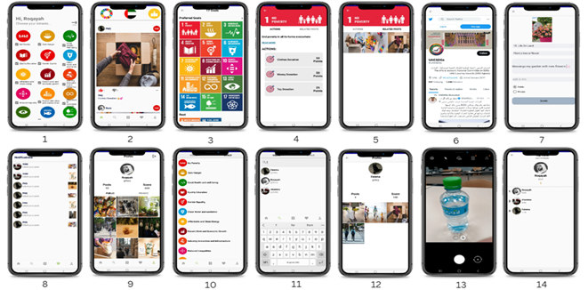

Figure all screens

Table UI screen brief description

|  |  |
| --- | --- |
| **Screen number** | **Description** |
| 1 | User selects her interest goal from the 17 goals. |
| 2 | The main page of the user. |
| 3 | The page of all goals with user-selected interests is on the top. |
| 4 | The page of a certain goal with a description, access to all posts related to this goal, and actions to do with this goal. |
| 5 | The related post to goal 1. |
| 6 | The page shows the latest UAE contribution in the sustainability field and activities. |
| 7 | New post page where the user can write the description and choose the goal and action. |
| 8 | A page that shows a notification when users interact with each other’s. |
| 9 | Profile of the user displaying posts and scores. |
| 10 | Search page with the option to search by a goal to see related posts. |
| 11 | Search page with the option to search by users to view users’ profile |
| 12 | Viewing another user profile. |
| 13 | Posting page where the user can take a picture or upload his action. |
| 14 | Ranking page of all users displaying results every 24 hours and a week. |

## Landing Page

|  |  |
| --- | --- |
| The landing page has the options of login and/or register for new user. | Figure Landing Page |
|  |  |

## Login Page

|  |  |
| --- | --- |
| The user must have user id and password to login.  User: u1  Pw: u12345678 (not visible)  User: u2  Pw: u23456789  The password will not be visible and it will be hashed in the DB. | Figure Login Page |

## Registration Page

|  |  |
| --- | --- |
| When the application has no account then she has to create an account. Figure 4 shows how to create an account for John  User: u3  Pw: u3456789  Once the account is created, the user is forwarded to the SDG goals to select his/her interests, see Figure 5 and Figure 6. | Figure 4 Login Page |
| Figure User is forwarded to the SDG goals to select his/her goals. | Figure Once registered successfully, the user is forwarded to the home page. |

## Home Page

|  |  |
| --- | --- |
| The first page will have 3 segments.   1. The goal main menu contains the following items: 2. Goal Information 3. UAE@Twitter 4. Ranking 5. Postings: lists all the postings that are relevant to the interesting goals registered by the current user 6. App Menu: standard menu that has the following action items: 7. Home 8. Search 9. Add post 10. Notifications 11. User Profile | Figure Home page |

## Goal Main Menu

|  |  |
| --- | --- |
| The goal main menu provides enough information and references to each goal of SDGs. User can select/register for specific goals deemed interesting for her. | |
|  | Figure The 17 SDG goals classified based on the user interests |
| Figure Goal general information, actions, references, links, etc. | Figure Edit option allows the user to edit goals |

## UAESDGs@Twitter

The official UAE government account for SDG on twitter can be used to read updated news on different events, achievements, and activities by the government divisions.

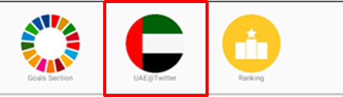

|  |  |
| --- | --- |
| Figure UAESDGs account on twitter. | Figure one of the government events, namely, COP28 |

## Ranking Page

The ranking page provides statistics on the most current influential events. It ranks activities and contributions by the users using point scheme.

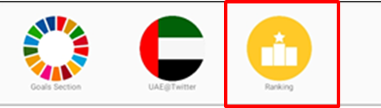

|  |  |
| --- | --- |
| Figure Ranking page, top 10 most influential activists are displayed. |  |

## Posting Segment

The posting segment lists postings and activities by other users who have similar SDG interest with the current user. The user can LIKE/DISLIKE postings and report inappropriate activities. Postings of the current user can only be deleted by the user, i.e., the user cannot LIKE/DISLIKE his own postings.

|  |  |
| --- | --- |
| Figure Postings of activists. The App shows the photo of the activity, goal icon, name of the user, number of LIKEs/DISLIKES, and option to report/remove the posting. | Figure Sample posting for SDG3 - Good Health posted by User U1. |

## App Main Menu

The application main menu includes standard actions. These actions include:

|  |  |
| --- | --- |
| 1. Home Page | The Home page is presented in Figure 4. |

|  |  |
| --- | --- |
| 1. Search: The action allows the user to search posting by Goal or by user. | Figure In searching by users, all users who posted activities that match the keyword will be displayed. |
| Figure In search by Goals, user selects the goal first. | Figure In searching by goals, all postings on the goal selected in Figure 14 will be displayed. |

|  |  |
| --- | --- |
| 1. Add post: this action allows the user to provide evidence of activities such as photo, link, or text. The user can add description and select the appropriate SDG/action. | Figure In posting activities, the user needs to provide image evidence and/or select the image from the phone. |
| Figure In posting activities, the user selects the Goal, action, and provide description and/or link. The posting can be either public or private. | Figure The posting will be viewed for the user and for all other users. |

|  |  |
| --- | --- |
| 1. User Profile: this action allows the user to see his own postings, ranking, scores, etc.   Additionally, the user can see and edit his profile that includes changing phone, email, photo, and reset her/his password. | Figure User Postings, points, and ranking. |
| Figure View/Edit User Profile |  |

|  |  |
| --- | --- |
| 1. Notification: this screen presents the opinion of other users with the current user postings. It notifies the user when another user liked/disliked the posting. | Figure User Postings, points, and ranking. |